**USER DOCUMENT FOR RELAY BOARD v1.0**

**User Document For Relay Board** **3**

Introduction 3

IO interface 3

Communication Interface 4

Demonstration using Modbus Poll Utility 4

# **User Document For Relay Board**

## **Introduction**

This document contains the details about Relay Board v1.1 for sensor master. It includes the connection details and communication protocol relay board.

## **IO interface**

Following image gives the connection for relay board v1.1

Following table gives the connection details for FRC Header:

| **Sr. No.** | **Pin No.** | **Signal Name** | **Description** |
| --- | --- | --- | --- |
| 1 | 1 | OUT_1 | This is output from the relay board and input to sensor master. Terminal J3 |
| 2 | 2 | IN1 | This is input1 to the relay board and output from the sensor master. A potential free contact is provided on this signal. Terminal - J8 |
| 3 | 3 | RX | This is TTL level UART RX signal of STM32F030F4P6 of relay board. |
| 4 | 4 | IN2 | This is input1 to the relay board and output from the sensor master. A potential free contact is provided on this signal. Terminal - J8 |
| 5 | 5 | TX | This is TTL level UART TX signal of STM32F030F4P6 of relay board. |
| 6 | 6 | IN3 | This is input1 to relay board and output from sensor master. An potential free contact is provided on this signal. Terminal - J8 |
| 7 | 7 | GND | This is supply ground signal |
| 8 | 8 | IN4 | This is input1 to relay board and output from sensor master. An potential free contact is provided on this signal. Terminal - J8 |
| 9 | 9 | 12V | This is +12V supply signal |
| 10 | 10 | GND | This is supply ground signal |

## **Communication Interface**

There are four digital optically isolated IOs provided on the relay board. These IOs can be accessed via MODBUS RTU protocol. Following table gives the command and register description to access IOs.

| **Sr. No.** | **Parameter** | **Registers** |
| --- | --- | --- |
| 1 | MODBUS slave id for relay board | 10 |
| 2 | Inputs | Starting Address - 8000  No of discrete inputs- 4  Range - 8000 - 8003  Input 1 address - 8000 ( Terminal J4 )  Input 2 address - 8001 ( Terminal J5 )  Input 3 address - 8002 ( Terminal J6 )  Input 4 address - 8003 ( Terminal J7 ) |
| 3 | Command to access Input | 02 - read discrete Inputs |
| 4 | Outputs | Starting Address - 4000  No of coils - 4  Range - 4000 - 4003  Output 1 address - 4000 ( terminal J13)  Output 2 address - 4001 ( terminal J14)  Output 3 address - 4002 ( terminal J15)  Output 4 address - 4003 ( terminal J16) |
| 5 | Command to control Outputs | 05 - write single coil  15 - write multiple coils |

## 

## **Demonstration using Modbus Poll Utility**

* Download and install modbus poll master utility. It is free for 30 days. Following is the link:

<https://www.modbustools.com/download.html>

* Connect USB to serial converter to the PC.
* Open modbus poll master utility.

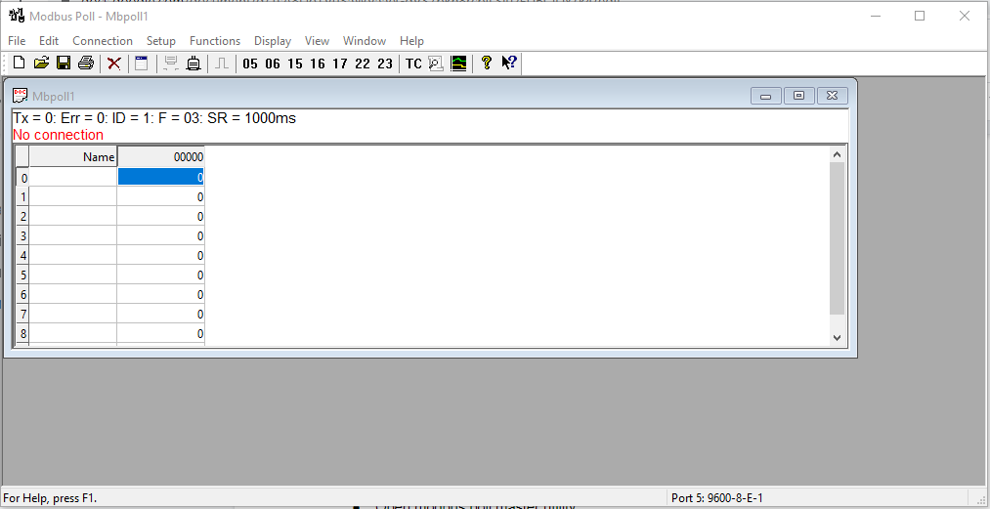

* Connect to the serial interface

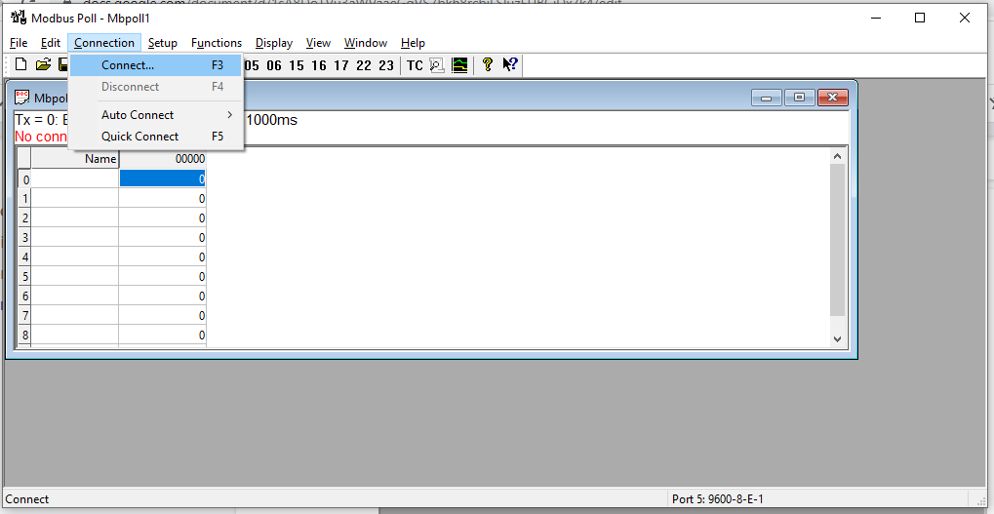

* Connect with following parameters

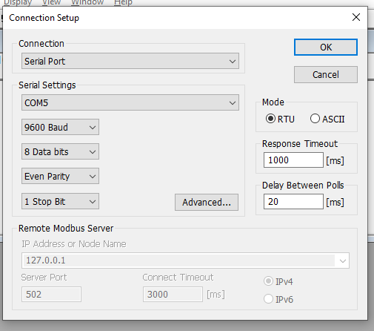

* To get input status. Goto -> setup-> read write definitions. And configure as per below and press OK

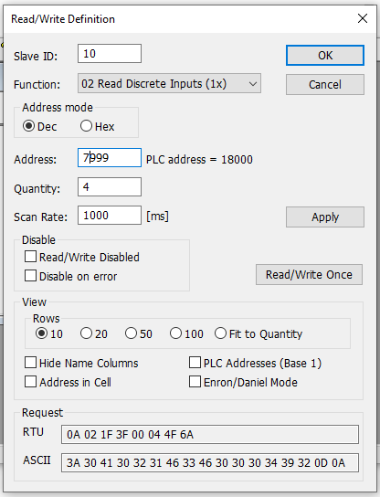

* The status of inputs can be observed in main window as shown below

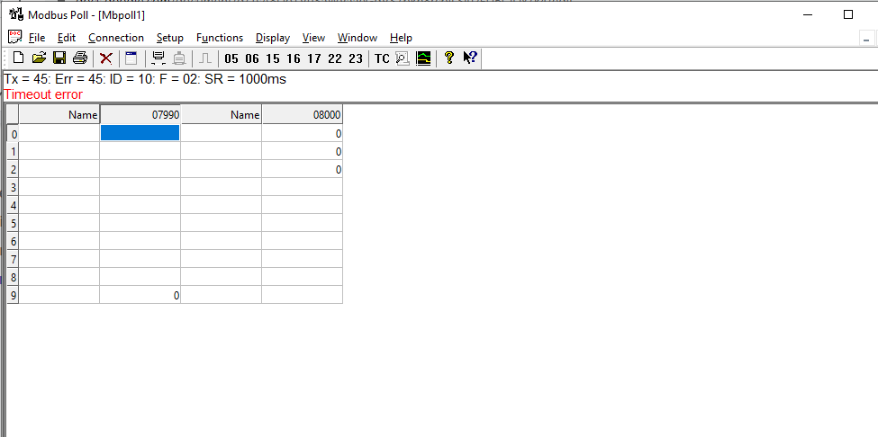

* To Control The outputs goto -> functions->select write single coil and configure as per below

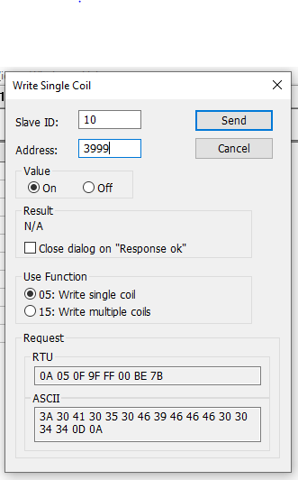

The coil can be turned on and off by selecting the value parameter.